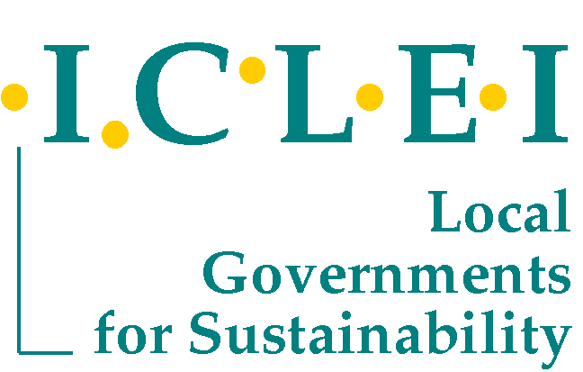
Senior Professional Officer: Sustainable Urban Development (Progressive experience in excess of 7 years)

Location: ICLEI Africa, Cape Town, South Africa

ICLEI – Local Governments for Sustainability (www.iclei.org) is the world´s leading association of cities and local governments dedicated to sustainable development. ICLEI is a powerful global movement of 12 mega-cities, 100 super-cities, 450 large cities and urban regions as well as 450 small and medium-sized cities and towns in 83 countries. It has a global and regional political governance structure which is led by visionary mayors from around the globe. It has a history of over 20 years of dedicated services to local governments, led by local government needs and realities. ICLEI has offices situated around the globe which enables lessons to be shared within and between regions and catalyses the rapid uptake of local solutions for sustainability. In addition, ICLEI provides substantial advocacy on behalf of local governments on sustainability, and in particular to the three Rio conventions.
The ICLEI Africa Secretariat (www.iclei.org/africa) provides professional services on sustainability to local governments and cities throughout the African continent. ICLEI Africa’s core work streams include: Waste, Energy and Climate Change (including Disaster Risk Reduction), Water and Sanitation, Urban Biodiversity, Green Urban Economy, Urban Food Security, Leadership and Governance, and Integrated Urban Planning.
ICLEI Africa offers an exciting opportunity to join our dynamic team of local government sustainability professionals.

Position: Senior Professional Officer

Requirements: • Degree in environmental science/management; urban planning; or social and development studies • Progressive experience in excess of 7 years • Conceptual, strategic and visionary thinker • Exemplary writing, research and presentation skills • Able to work independently and as part of a dynamic group • Strong organizational, financial and administrative skills • Proven project development and proposal writing experience • Ability to work across ICLEI work streams whilst providing substantial expertise in at least two work streams • Understanding of urban contexts and local government • Ability to engage high level officials with diplomacy and energy • Ability and willingness to travel is a pre-requisite •Additional language abilities (French, Portuguese and African languages) highly sought •

Key Performance Areas: • Project/programme management and implementation • Proposal development and report writing • Research and data gathering • Presentation, diplomacy, advocacy and communications outreach •

NOTE: Only applicants that are Residents of South Africa or hold a valid work permit/visa should submit their application.

Interested candidates must submit i) a letter of motivation with an indication of expected remuneration level, ii) proof of residency or working permit and iii) a CV to: Ms L Naude, HR Director, 71 Burg Street, Cape Town. E-mail: louise.naude@iclei.org

Closing Date: 17h00, 3rd July, 2013.

If you have not been contacted within 14 days of the closing date of this advertisement, please accept that your application was unsuccessful.

