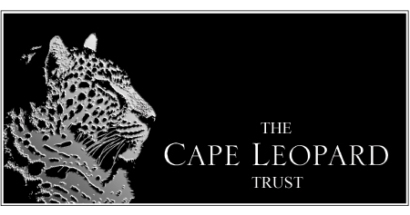

Trust Number: IT 2720/2004
PBO Number: 930 016 841

Environmental Educator – Cape Leopard Trust

The Cape Leopard Trust is seeking a suitably qualified ‘Environmental Educator’ to run its camps in the Cederberg Mountains and to manage its Cape Town based education programme. The candidate must hold a valid driving license, be physically fit, have outdoor experience and be willing to work for extended periods in a remote location.

Reporting to the Project Coordinator the key performance areas are:

Good leadership skills
Facilitating hikes and outdoor activities
Group management and mentoring
Practical campsite experience including maintenance
Conducting presentations and visits to schools
Maintaining relationships with environmental education partners
General administration and curriculum development
The ability to work independently under pressure or as part of a team
To be a responsible and presentable ambassador for the trust

Qualification and experience requirements:
Matric or equivalent qualification
Teaching or guiding experience is an advantage
Computer literacy and communication skills
A code 10/C1 driving license preferable
Fluency in both English and Afrikaans with knowledge of an African language desirable

Location: Cape Town and the Cederberg Mountains

Remuneration: R150 000 – R180 000 per annum

Individuals who meet these requirements should forward their CV together with a motivational letter to Elizabeth Martins, Education Project Coordinator at elizabeth@capeleopard.org.za
by the closing date: 31 July 2013

Start date: October 2013 with 3-month training/probation period.

The Cape Leopard Trust is guided by the principles of employment equity. Information on our organisation is available on our website: www.capeleopard.org.za

If you have not received a response within 14 days of the closing date, please assume your application has not been successful.

The Cape Leopard Trust reserves the right not to make an appointment to the position as advertised.

