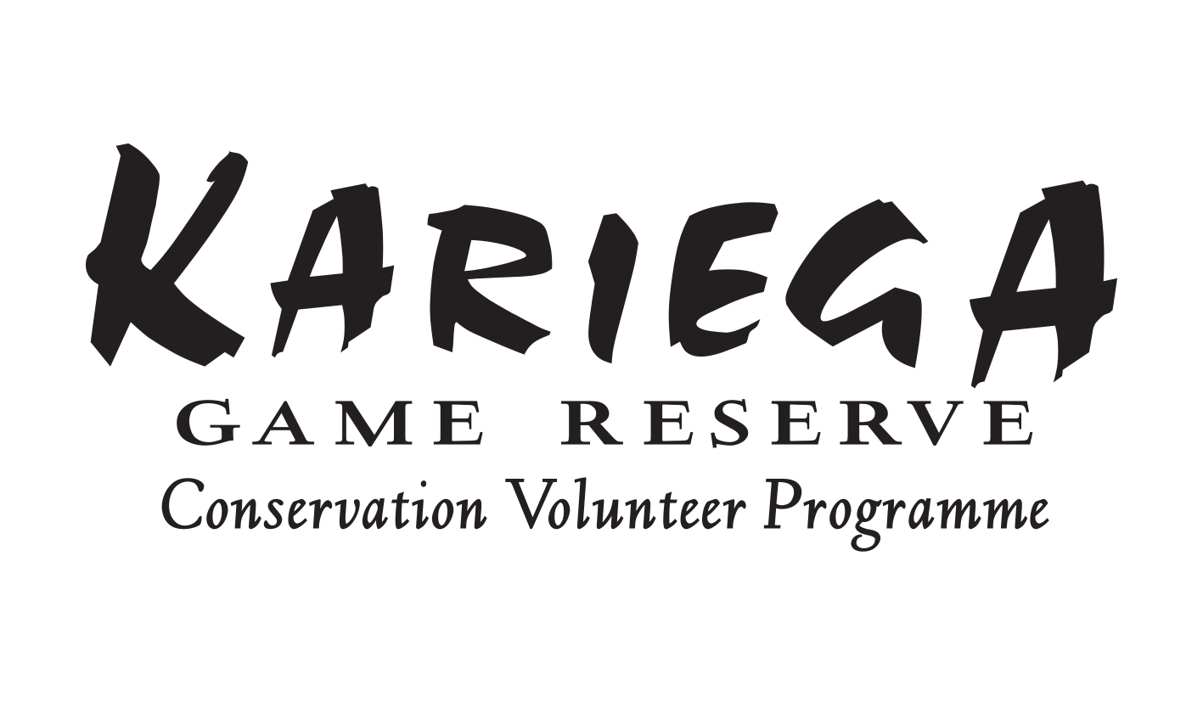

POSITION AVAILABLE:

Conservation Volunteer Coordinator: Kariega Game Reserve

(9 000 ha Private Big 5 Game Reserve in the Eastern Cape)

Conditions of service

Job description

The coordinator is required to facilitate a varied conservation management experience for visiting foreign volunteers. Activities are both educational and physical, and may vary from game counts, determining of various species sex ratios, reserve clean-up operations and alien plant control to lion tracking and prey selection study, leopard camera trap monitoring and elephant impact monitoring. The coordinator is given much scope to introduce and develop new work activities and research projects. Opportunity and support is available for those who may want to further their education through research on the reserve. Applicants can go to www.kariega.co.za (click on conservation volunteer programme) for more information regarding the conservation volunteer programme and possible work activities that the coordinator might be involved with.

Applicants must be familiar with the process of scientific data collection and analyzing. The volunteer programme forms an integral part of the conservation department on the reserve and the coordinator is responsible for most of the monitoring on the reserve.

Certain administrative tasks are also required of the volunteer coordinator – a comprehensive annual report, monthly newsletters and managing the volunteer programme Facebook page.

Training and education

Candidates with no formal training in the conservation field need to have at least FGASA level 2 and a fair amount of experience with excellent “bush” knowledge.

Candidates with formal conservation training and little experience require a B-tech in Nature Conservation or an Honours degree in Conservation Ecology/Wildlife management or another comparable equivalent.

Gender & age requirements

Healthy, physically fit male and female applicants, 22 years or older will be considered for the position. Due to the very social nature of the position and the fact that most of the volunteers are youngsters between the ages of 17 and 26, we feel that the position is most suited to a young conservationist, between the age of 22 and 28.

Life skills

Confidence, excellent communication skills, and a hardworking “carpe diem” attitude towards life are required of the volunteer coordinator. The position is also most suited for a very social “peoples” person, that works well in a group and that is able to socialize with a broad spectrum of personalities. Applicants must be natural leaders that can take charge of a group situation and must be able to make decisions and work well without the guidance of a supervisor.

It will also be of benefit if the applicant is practically minded and able to attend to minor maintenance problems from time to time like fixing a water pump.

Applicants should be in possession of a valid code 08 driver’s license and should be willing to obtain a Professional Driver Permit (PDP). A valid level 1 first aid certificate to become registered with DEAT is also a requirement. The successful candidate must be willing to register him/herself with DEAT in order to meet with the Department’s guidelines for the nature guiding industry.

Due to the location, all applicants must have their own vehicle.

Salary & benefits

- The monthly salary is R5 500 plus an extra R50 per volunteer per week. If for example the programme runs at full capacity where the coordinator is in control of 10 volunteers, the monthly earnings will come to around R8 000. If only four volunteers are at the programme during the month, the coordinator’s monthly earnings will be around R6 500.

- A small eating-out allowance is given for Saturdays when the coordinator is expected to take the volunteers to town.

- A R200 monthly cellphone allowance is also given to cover the coordinator’s expenses for business phone calls

- Accommodation on Kariega Game Reserve is provided (included free lights and water)

- The volunteer coordinator can choose to eat some suppers with the volunteers at the volunteer house.

Working days & leave cycles

The coordinator’s working week is from Monday to Saturday. Mondays to Fridays are working days on the reserve and on Saturdays the coordinator takes the volunteers to a nearby town or an arranged outdoor activity like beach horse riding, skydiving ect. Sundays the coordinator is off.

The volunteer coordinator will get 6-7 weeks paid leave per annum. The coordinator needs to be flexible in terms of when the leave is given, as it depends on volunteer bookings. Generally 2 weeks leave will be given around May, 2 weeks again in October and 2-3 weeks over the Christmas/New Year period (the programme is closed every year over Christmas/New Year so leave will always be given for this period).

Starting date

Two weeks training with the current volunteer coordinator in September – exact dates to be confirmed.

Officially commencement date is the 23rd of September 2013. First group for the new volunteer coordinator to be in charge of arrives on the 21st of October.

Contact person

Helena Warren

Please email CV’s to: volunteer@kariega.co.za
Phone: 076 100 6809

