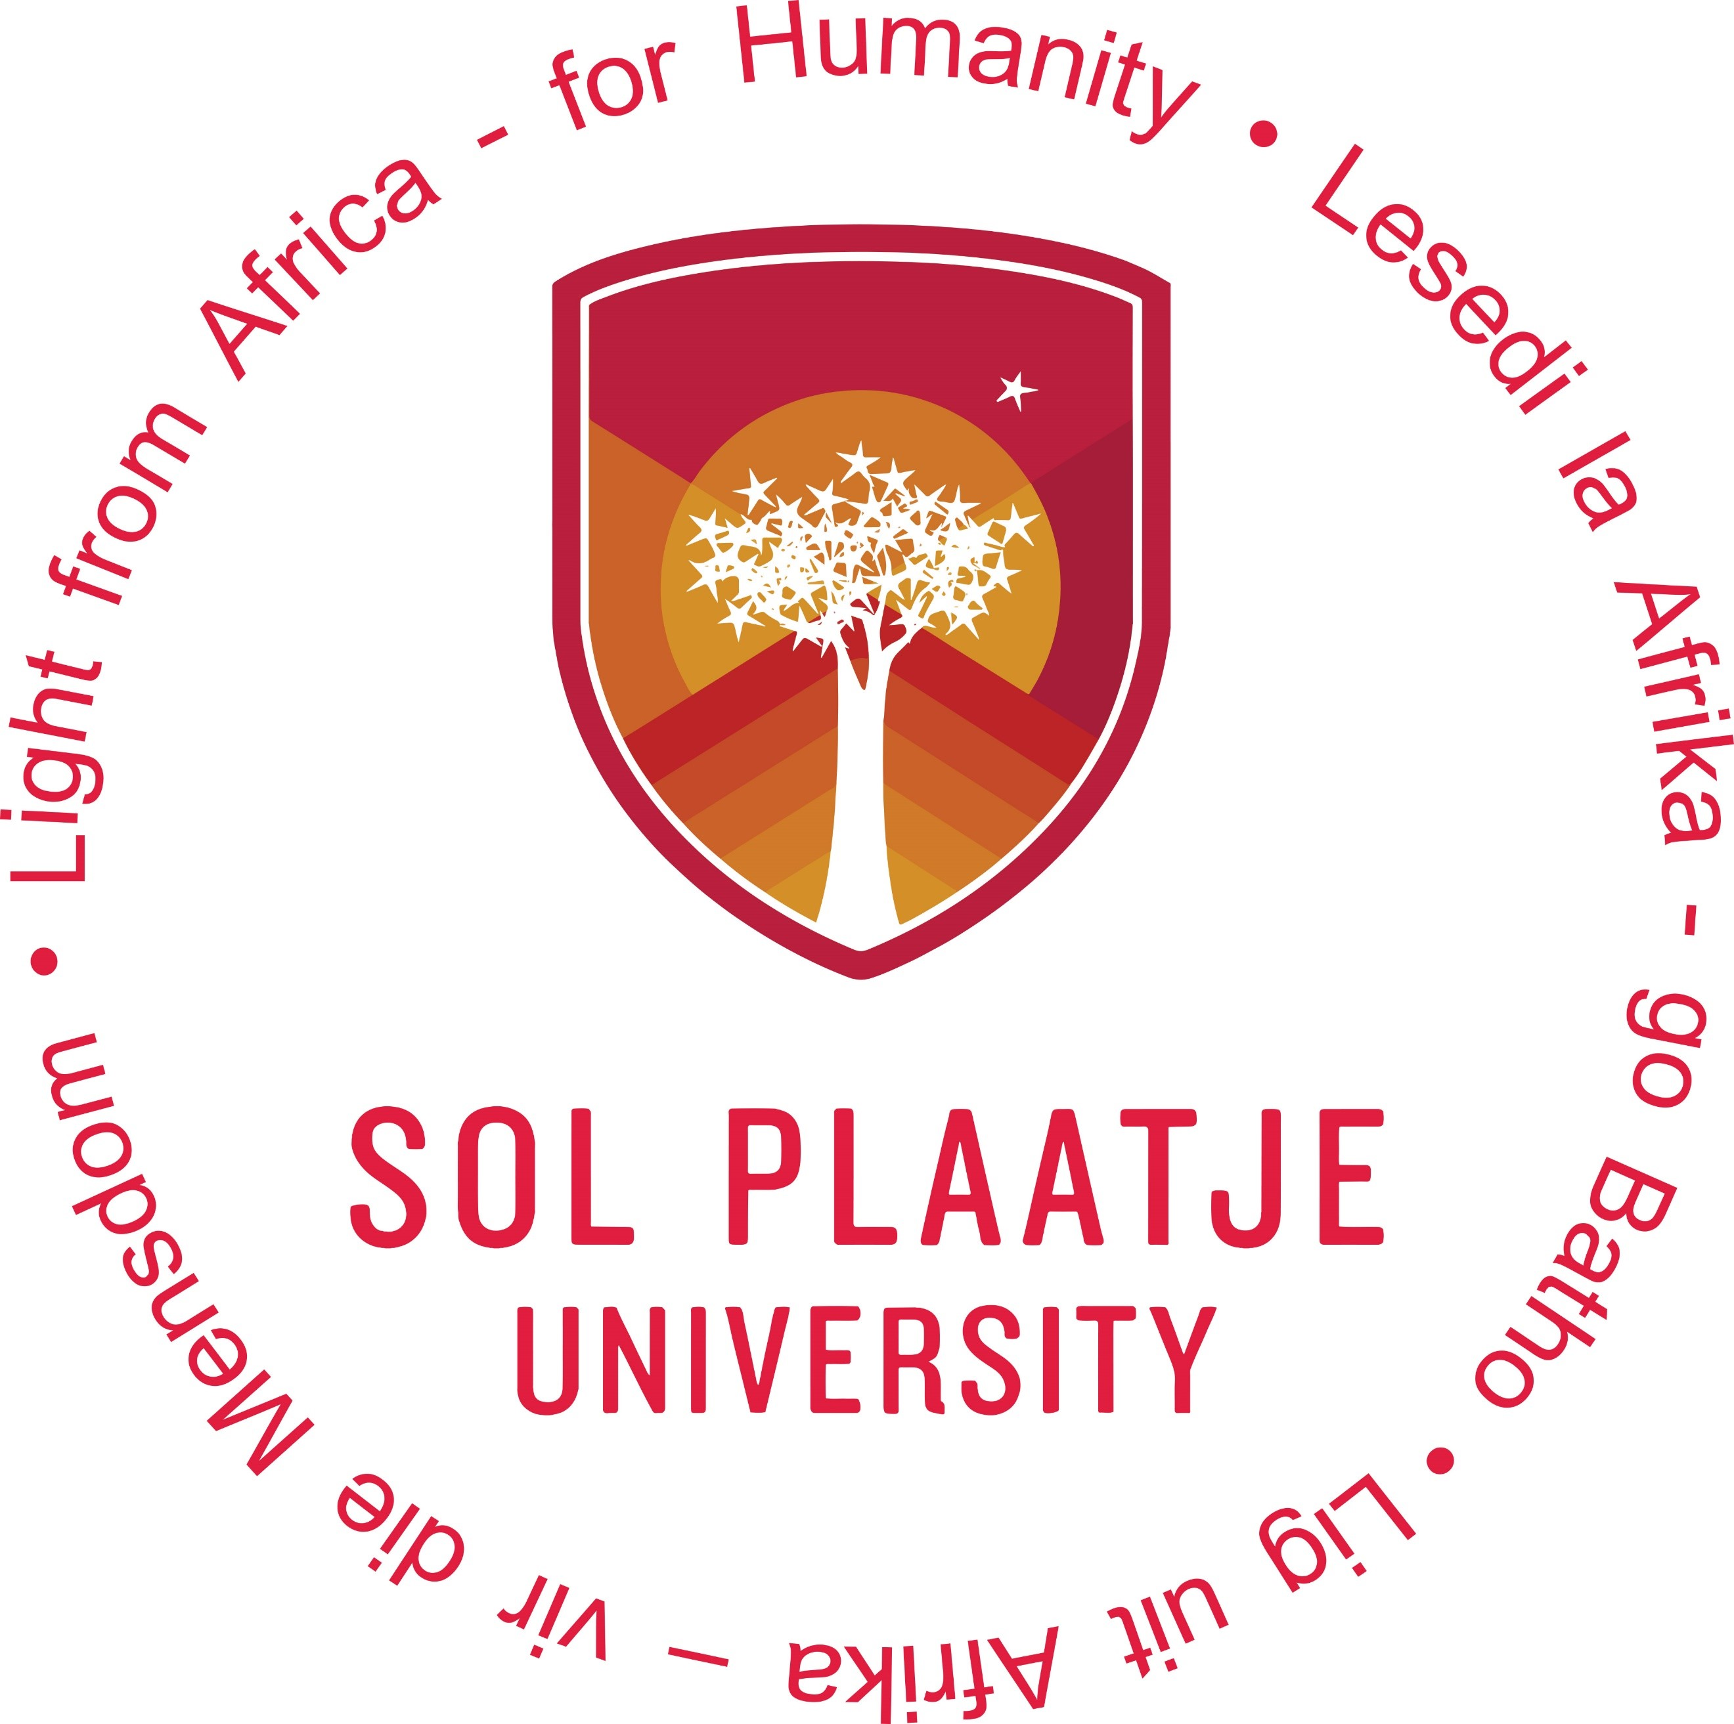

FIRST CALL FOR PAPERS
BIENNIAL CONFERENCE OF THE HISTORICAL ASSOCIATION OF SOUTH AFRICA (HASA)
SOL PLAATJE UNIVERSITY, KIMBERLEY
18 TO 20 JUNE 2025

HERITAGE, HISTORY AND HISTORIOGRAPHY – FROM THE LOCAL TO THE REGIONAL AND CONTINENTAL

HASA invites historians as well as students and researchers in related or relevant disciplines to submit papers for an international conference entitled Heritage, History and Historiography – From the Local to the Regional and Continental to be held at Sol Plaatje University (SPU) in Kimberley, Northern Cape from 18 to 20 June 2025. Papers of a theoretical nature, as well as ones addressing case studies, will be welcomed. The organisers, in the first instance, are calling for papers which address the conference theme. But, as this is a general conference of HASA, papers on other topics will be welcome as well. Those of you who would like to focus on the conference theme may of course use your own initiative and points of departure. The following may, however, stimulate more ideas:

In recent years, there have been radical challenges to the received consensus on the nature of historical inquiry, sources utilised by historians and the boundaries of the discipline. The development of technology and the impact of Covid-19 pandemic lockdowns have led to exciting opportunities for new methods of teaching and research, and opened new opportunities for collaboration crossing local, national and international boundaries. We envisage that presentations at this conference will take up the challenges posed by these developments to present papers on topics and in fields not usually covered by History conferences. Contributions by both well-established and newer academics are equally welcomed. Papers read by post-graduate students are encouraged. Supervisors and mentors are encouraged to accompany their postgraduate students to the conference. Some suggested areas could be:
- Historiography
- Environmental History and Historical Ecology
- Medical History and Disease Studies
- Pandemics and Epidemics
- New Directions in History Teaching and Research
- Decolonisation of History and Heritage Curriculum
- Historical Studies, Artificial Intelligence and Social Media
- Sound, Film and Media Studies
- Local, Urban and Regional Histories
- Literary History
- Art History
- Oral Histories
- Microhistories
- Biographies
- Heritage and Historical Archaeology
- Palaeontology, Genetics and Forensic History
- Resistance, Wars and Conflict in Southern Africa
- Mineral Revolution, Industrialisation and its aftermath
- Indigenous Peoples/Communities of the Northern Cape – past and present communities
- Mining Histories
- Missionary Societies, Missionaries and Mission Converts
- Prophets and Religious Protest Movements
- Land, Labour, Migration and the Diaspora
- Sport History
- Social History
- Hauntology and the Ghosts of the Past
- Written Culture, Travel Writing and the History of Travel
- Archives and Archiving/Rethinking the Archive
- Public History and History as Performance
- New Areas of Historical Enquiry – Surprize us!

Abstracts (200 words maximum), together with affiliation and all contact details, should be submitted to the following email address: HASA2025@spu.ac.za
Conference organisers: Dr Cobus Rademeyer cobus.rademeyer@spu.ac.za and Dr Karthi Gopalan karthigasen.gopalan@spu.ac.za.

Abstracts should be submitted by 15 March 2023.

Please copy abstract to both organisers. Participation is in-person only – there will be no hybrid sessions. Abstracts will be reviewed by an appointed review committee and conference organisers.

Delegates will have to do their own reservation and accommodation booking. Accommodation is available at very favourable rates and there are several, guest houses Bed-and-Breakfast establishments and hotels in and around Kimberley. A list of guesthouses/bed-and-breakfast establishments and Hotels can be provided on request. The fees will cover the conference, including teas/coffees, lunches and cocktail/dinner. Accommodation and travel are for the account of the attendee/delegate and is not included in the registration fees. The conference will be hosted in mid-June and therefore delegates need to dress warmly (jackets and jerseys).

Kimberley airport is located about 8 minutes from Sol Plaatje University and most places of accommodation. Flights from Cape Town and Johannesburg to Kimberely and vice versa are limited. Only two airlines operate flights between Cape Town and Johannesburg to Kimberley: Airlink and CEM Air. The conference costs are as follows:

Delegate University Staff @ R2 500.00 per delegate (refreshments, lunch and cocktail dinner included)

University Academic – member of HASA – registration fee – @R2200 per delegate (refreshments, lunch and cocktail dinner included)
Delegate Postgraduate Student @ R1 500.00 per delegate (refreshments, lunch and cocktail dinner included)

